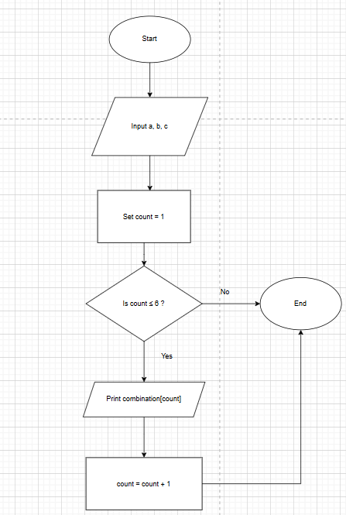
ALGORITHM
- Start
- Input three digits a, b, c
- Store them in a list digits = [a, b, c]
- For i from 0 to 2
For j from 0 to 2
For k from 0 to 2
If i ≠ j AND j ≠ k AND i ≠ k
Print digits[i] digits[j] digits[k]
- Stop

7.1.2 POSSIBLE COMBINATIONS FROM THREE DIGITS

